Report on Bridge Course 2019
Department of Economics
Bridge course duration 08-07-2019 to 10-07-2019
Economics Department has conducted the bridge course in three days from 08/7/2019 to 10/7/2019 9.30 am to 3.30 pm. The inaugural function presided by Basheer KT. The inaugural speech was conducted by Mujeebrahman AP (HOD of Department of Economics).
The first session were headed by Basheer KT (department of Economics). His theme was “Self-Motivation and Achievement”. It was a theoretical oriented class. Afternoon Session was handled by Thesnimol ( Department of Economics). It was an activity oriented session.
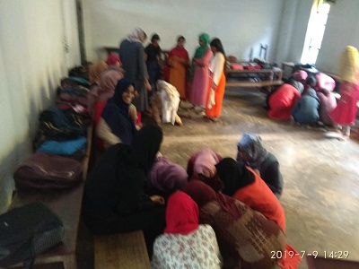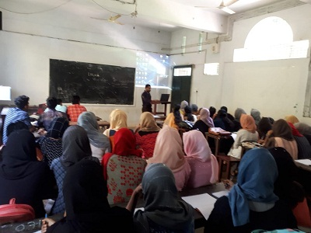
On 09-7-2019, the morning session was handled by Mr Mujeebrahman A.P HoD , Departmentof Economics).The second session was handled by TPO Ashrafali , The Assistant Professor in Computer Science, SS college on “importance of computer application in day-to-day life. Afternoon Session was handled by Jabir Amani, HOD, Department of Arabic on ‘Market yourself’. It was an activity oriented session.
On Last day, 10-7-2019, the morning session was headed by Lukuman Areakode, a well Known speaker on achievement, motivation and personality development. He addressed the students on “Motivation and Achievements” The afternoon session was handled by Mr Rinju Vellila, an artist ad also teacher, the session was titled “learn by assimilating and accommodating the nature
The last session was feedback and evaluation. Basheer K.T handled the session, he Collected feedback and conducted evaluation about the course and conclude the session on 4’o clock.
